1.Draw and label a simple home network diagram showing a router, switch, and three devices (like a laptop, smartphone, and smart TV), indicating how each device connects to the network.
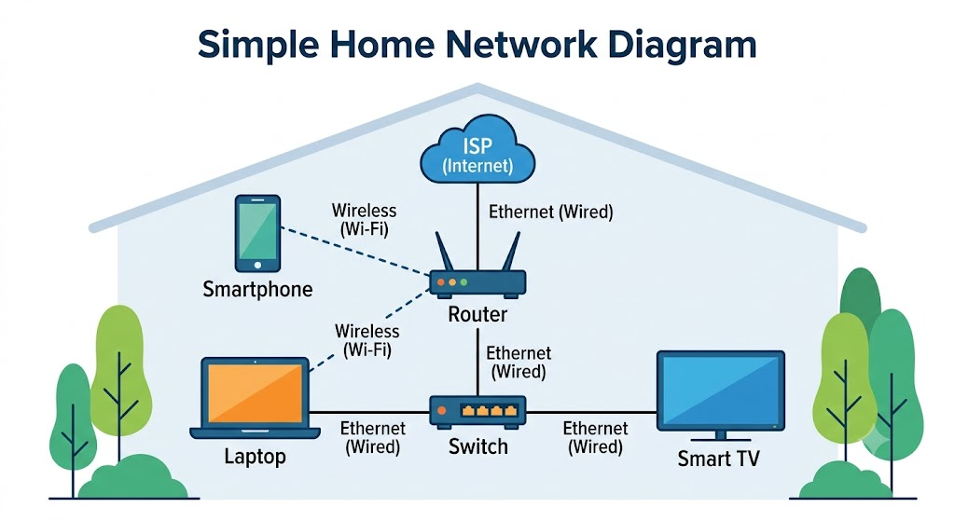
2.Create a comparison table listing at least four network devices (router, switch, hub, access point) and describe one real-world use case for each, referencing apps or services you use daily (e.g., WiFi for streaming on YouTube, LAN gaming, etc.).
Network Device | Primary Function | Core Layer (OSI Model) | Real-World Everyday Use Case
Router | Connects completely different networks together (like your home network to the global Internet) and routes data packets between them. | Layer 3 (Network Layer) | Streaming Netflix or YouTube: When you tap a video on your phone, your home router takes that request and directs it out to the Internet to find Google or Netflix's servers, bringing the video stream safely back to your house.
Switch | Connects devices within the same local network (LAN) and intelligently forwards data only to the specific device it was meant for using MAC addresses. | Layer 2 (Data Link Layer) | Lag-Free LAN Gaming: If you plug your PC and a friend's console into a network switch for a local multiplayer game (like Counter-Strike or Valorant), the switch passes data directly between your machines at lightning-fast speeds without congesting the rest of the house's internet.
Hub | Connects devices within a local network, but unlike a switch, it is "dumb"—it blindly broadcasts copies of incoming data to every connected port, causing network congestion. | Layer 1 (Physical Layer) | Legacy Office Setup or Basic Network Monitoring: Because hubs are outdated and inefficient, you rarely see them today. However, a tech enthusiast might use an old hub to easily plug in a packet analyzer (like Wireshark) to monitor all traffic passing through a couple of older legacy devices.
Wireless Access Point (WAP) | Plugs into a wired router or switch via an Ethernet cable and projects a Wi-Fi signal so wireless devices can connect to the wired network. | Layer 2 & Layer 1 | Scrolling TikTok/Instagram on the Couch: When your phone is connected to Wi-Fi, it transmits data wirelessly to the Access Point. The AP converts those wireless radio waves into wired signals to send through the walls back to your main modem/router.

3.Write a short scenario where you explain how data travels from your phone to the internet when you order food on Zomato, mentioning the role of each network device involved (router, switch, access point).
The Scenario: Ordering Dinner
You tap "Place Order" on your phone for a pizza. Your phone converts this action into digital data packets.

[Phone] ----(Wi-Fi)----> [Access Point] ----> [Switch] ----> [Router] ----> [Internet]

4.Given this situation: you have a WiFi router, but your gaming PC only has an Ethernet port and is far from the router. Suggest two different network devices you could use to connect your PC to the internet and explain how each would work in this setup.<br><br><em><strong>Hint:</strong> Think about devices like switches, powerline adapters, or WiFi extenders.</em>
Here are two network devices that can solve this problem:
1. Powerline Adapter Kit
- How it works: This kit includes two adapters. You plug the first adapter into a wall outlet near your router and connect them via an Ethernet cable. You plug the second adapter into a wall outlet near your gaming PC and connect it to your PC's Ethernet port.
- The Connection: The adapters turn your home’s existing electrical wiring into a wired network cable, sending the internet signal straight through the walls without relying on a Wi-Fi signal.

2. Wi-Fi Extender (with an Ethernet port)
- How it works: You place the Wi-Fi extender in a location where it can still receive a strong wireless signal from your router. You then run an Ethernet cable from the port on the extender directly into your gaming PC.
- The Connection: The extender acts as a bridge; it captures the wireless Wi-Fi signal from your router and translates it into a wired connection for your PC.

